Rep_Lab_Final_B0829002

Simple Computer with branch control

RTL View:

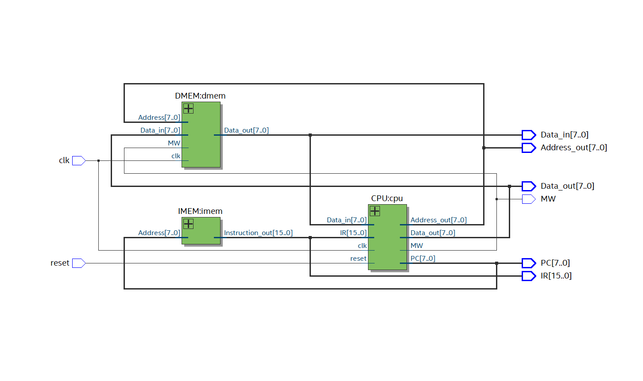

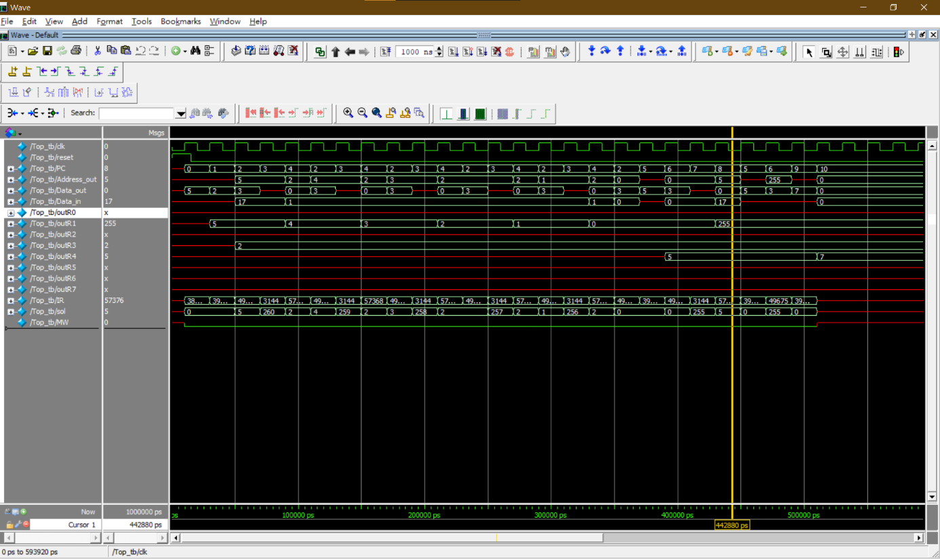

In this Task, we are going to make a branch control with rewrite CPU.v file.

In the Basic, we are going to connect the datapath from Lab 07 with the CUP, which was provided. And we are going to check the RTL View for this connected new simple computer.

In the Bounces 1st, we need to using modelsim to simulate the execution of instruction code and make sure that is same as the simple computer file’s simulation from Modelsim, which was provided.

In the Bounces 2nd, we need to design a branch control instruction to make sure the branch control, which we are designed, can work. And using Modelsim to check the waveform is same.

Discussion:

I learn a lot from this lab, such as how to design a branch control unit to make the programming counter can doing Register instruction, Immediate instruction, and branch instruction. And what more, I also known how to check the waveform to make sure the operation and branch, Jump is right or not. In my opinion, That is quite important to simulate a waveform for computer designing. And I also learn a lot of tips to make my design doing efficient better.

Difficult and tips:

The most difficult part I thought was to check the waveform was same as the example waveform. Because we need to know all instruction and how they work. Thus, we can let all register out to check the operation of the instruction are correct. That can make the value in Registers easily looked and to analysis.